**Software Engineering Assignment**

**Module : 1 (SDLC)**

* What is software? What is software engineering?

- Software is **a set of instructions, data or programs used to operate computers and execute specific tasks**. It is the opposite of hardware, which describes the physical aspects of a computer. Software is a generic term used to refer to applications, scripts and programs that run on a device.

There are different types of software that can run on a computer: **system software, utility software, and application software**.

Software engineering is **the process of developing, testing and deploying computer applications to solve real-world problems by adhering to a set of engineering principles and best practices**.

Examples of technical skills for software engineers include **computer language programming and coding, software testing, debugging, database management**, etc.

* Explain types of software?
* There are mainly five types of software which are:
* Application Software.
* System Software.
* Driver Software.
* Middleware Software.
* Programming Software.
* **Application Software :-**

An application program (software application, or application, or app for short) is **a computer program designed to carry out a specific task other than one relating to the operation of the computer itself, typically to be used by end-users**. Word processors, media players, and accounting software are examples.

* **System Software :-**

System software is a type of computer program that is designed to run a computer's hardware and application programs. If we think of the computer system as a layered model, the system software is the interface between the hardware and user applications. The operating system is the best-known example of system software.

* **Driver Software :-**

In the most fundamental sense, a driver is **a software component that lets the operating system and a device communicate with each other**. For example, suppose an application needs to read some data from a device.

Like audio driver, video driver, etc.

* **Middleware Software :-**

Middleware is **software that lies between an operating system and the applications running on it**. Essentially functioning as hidden translation layer, middleware enables communication and data management for distributed applications.

For example, **a web server** is middleware that connects websites to the backend database. When you submit it a form on a website, your computer sends the request in XML or JSON to the web server.

* **Programming Software :-**

Computer programmers use programming software to write code. Programming software and programming tools enable developers to develop, write, test and debug other software programs. Examples of programming software include **assemblers, compilers, debuggers and interpreters**.

* What is SDLC? Explain each phase of SDLC
* **The Software Development Life Cycle (SDLC)**is a process used by software development organizations to plan, design, develop, test, deploy, and maintain software applications.

**SDLC (Software Development Life Cycle)** is used in Every Software Development Company because it is the root of the Development Cycle, if that model would not exist in the world, firstly no software can build secondly if any how it would be made, it’s not going to succeed it has no use, because of no maintenance, but Luckily SDLC model exist in Tech world **But why we need it Actually!**

There are several reasons why organizations use the Software Development Life Cycle (SDLC) when developing software applications:

To provide a **structured and organized approach**to software development: The SDLC provides a framework for managing the software development process, which helps to ensure that all necessary steps are taken and that the final product meets the requirements.

1. **Requirements gathering and analysis:** This phase involves gathering information about the software requirements from stakeholders, such as customers, end-users, and business analysts.

**2. Design:** In this phase, the software design is created, which includes the overall architecture of the software, data structures, and interfaces. It has two steps:

* **High-level design (HLD):** It gives the architecture of software products.
* **Low-level design (LLD):** It describes how each and every feature in the product should work and every component.

**3. Implementation or coding:** The design is then implemented in code, usually in several iterations, and this phase is also called as Development.

things you need to know about this phase:

* This is the longest phase in SDLC model.
* This phase consists of Front end + Middleware + Back-end.
* **In front-end:**Development of coding is done even SEO settings are done.
* **In Middleware:** They connect both the front end and back end.
* **In the back-end:** A database is created.

**4. Testing:**The software is thoroughly tested to ensure that it meets the requirements and works correctly.

**5. Deployment:** After successful testing, The software is deployed to a production environment and made available to end-users.

**6. Maintenance:**This phase includes ongoing support, bug fixes, and updates to the software.

There are **different methodologies** that organizations can use to implement the SDLC, such as**Waterfall, Agile, Scrum, V-Model**and**DevOps.**

* What is DFD? Create a DFD diagram on Flipkart
* **DFD** is the abbreviation for **Data Flow Diagram**. The flow of data of a system or a process is represented by DFD. It also gives insight into the inputs and outputs of each entity and the process itself. DFD does not have control flow and no loops or decision rules are present. Specific operations depending on the type of data can be explained by a flowchart.

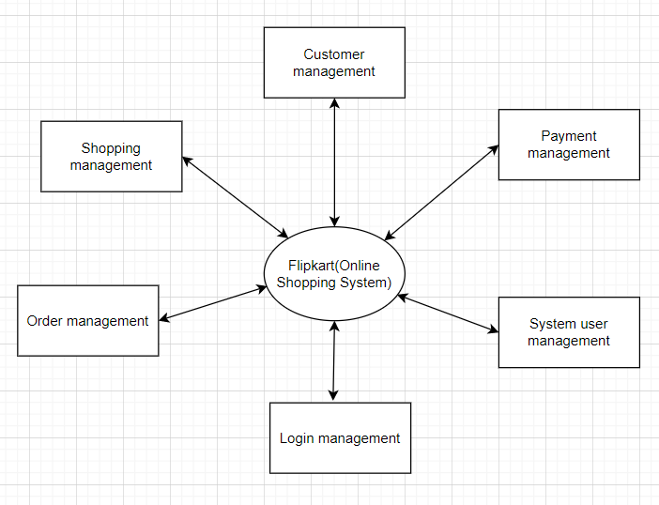

DFD-0 (Level 0)

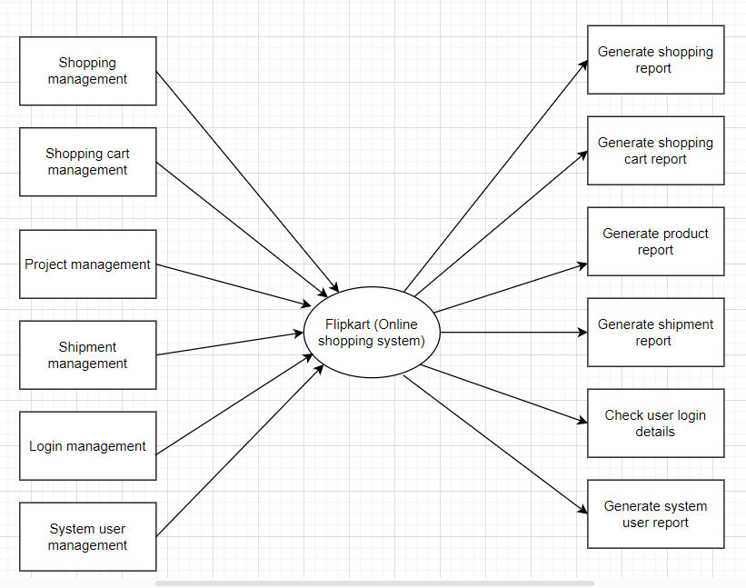

DFD-1 (Level 1)

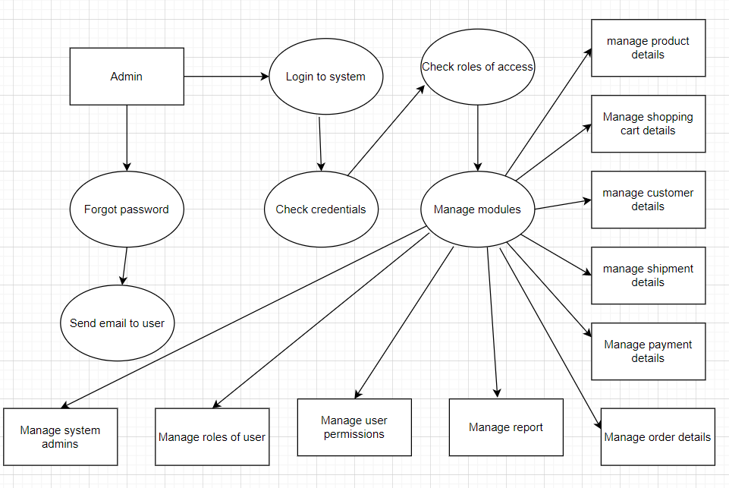

DFD-2 (Level 2)

* What is Flow chart? Create a flowchart to make addition of two numbers
* A **flowchart** is a type of [diagram](https://en.wikipedia.org/wiki/Diagram) that represents a [workflow](https://en.wikipedia.org/wiki/Workflow) or [process](https://en.wikipedia.org/wiki/Process). A flowchart can also be defined as a diagrammatic representation of an [algorithm](https://en.wikipedia.org/wiki/Algorithm), a step-by-step approach to solving a task.

The flowchart shows the steps as boxes of various kinds, and their order by connecting the boxes with arrows. This diagrammatic representation illustrates a solution model to a given [problem](https://en.wikipedia.org/wiki/Problem_solving). Flowcharts are used in analyzing, designing, documenting or managing a process or program in various fields.

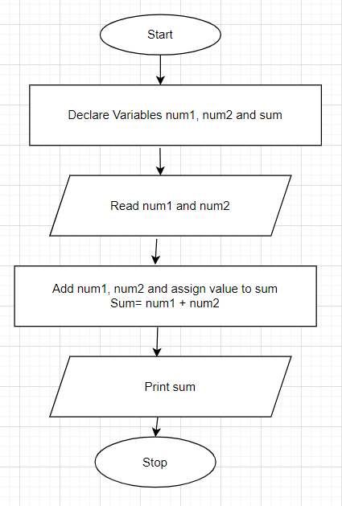

* What is Use case Diagram? Create a use-case on bill payment on paytm.
* Use-case diagrams **describe the high-level functions and scope of a system**. These diagrams also identify the interactions between the system and its actors. The use cases and actors in use-case diagrams describe what the system does and how the actors use it, but not how the system operates internally.

